**PRESS RELEASE**

New GRI Sustainability Report

Assurance Standard by FBRH UK

Globally, the only Assurance Standard that is specific for GRI Standards sustainability reports and that is also designed to Increase Positive Change (IPC)

www.fbrh.co.uk has launched a Sustainability Report Assurance Standard. As the only assurance globally that is specific for GRI Standards reports, it is filling a gap in the market that has been long overdue. It aims to increase both the quality of GRI reports and the pace of change and the number of companies affecting positive change on the environment, economy and society.

The GRI sustainability reporting standards are the most popular in the world, with 80% of the world’s largest 250 companies using them for their reports. Most importantly, they are the world’s only complete set of standards that uniquely address all the Sustainable Development Goals (SDGs) and are the recommended framework for reporting by the UN Global Compact.

Sustainability reporting is an essential tool for businesses to identify their most important impacts and then proceed to measure, manage and change. Simon Pitsillides, founder of FBRH said that

“In our world today with a population of more than 7 billion people it has become essential that we embed a culture of sustainability in the majority of businesses worldwide. Our complicated world requires that we are all part of a system that is aware of all negative impacts (environmental, social and economic) and takes action to mitigate these before they become problems, like climate change.”

The main characteristics of the FBRH Sustainability Report Assurance (for GRI reports) are:

﻿✓ **Designed to Increase Positive Change** (IPC)

✓ Helps companies be part of the bigger picture with action to increase positive change. Across the world, there is an unprecedented drive towards sustainability. Companies that fully engage are at the forefront and [well-prepared to gain competitive advantage](https://sustaincase.com/are-your-competitors-better-prepared/).

✓ Helps create a [culture of sustainability](https://fbrh.co.uk/en/culture-of-sustainability) with different levels of Assurance.

✓ **Designed to improve quality in both assurance and GRI sustainability reports**

✓ **Available to all assurance providers worldwide.** FBRH Assurers must be GRI exam holders. A prerequisite, designed to limit superficial assurance practices. It can be easily seen if individuals have the knowledge to assure a GRI report, as their names also appear on the GRI website. This is an important prerequisite, designed to increase quality in both assurance and GRI sustainability reports.

✓ **Globally, the only GRI Standards Sustainability Report-Specific Assurance Standard**

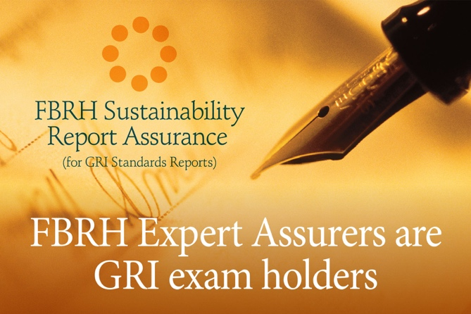✓ **Affordable starting price even for smaller companies:** with a starting price of £2800+vat for the FBRH Basic Sustainability Report Assurance (confirms that all necessary requirements by GRI have been met)

**About FBRH**

FBRH Consultants were founded in 2001 and are experts on the GRI Standards. They are a United Kingdom Global Reporting Initiative (GRI) and Institute of Environmental Management and Assessment (IEMA) certified training partner. FBRH UK has partnered with the CIM and mapped out the content of the FBRH GRI Standards Certified, IEMA and CIM recognised course against their unique Professional Marketing Competencies.

﻿Expert FBRH GRI Sustainability Report Assurers are also GRI exam holders and assure that your report can be trusted to be in accordance with the GRI Standards.

<https://fbrh.co.uk/en/gri-sustainability-report-assurance>

|  |
| --- |
| **Notes to editors:**  Media contact: Melina Kourri (Client Relations), [melina.kourri@fbrh.co.uk](mailto:melina.kourri@fbrh.co.uk?subject=Enquiry:%20FBRH%20Sustainability%20Report%20Assurance%20(for%20GRI%20Reports))  **Key facts about FBRH**   * Founded in 2001. * FBRH is the acronym of the definition of the word trust:   FBRH = Firm Belief in Reliability and Honesty.   * Experts in GRI Standards Reporting and Certified Training:   + United Kingdom Global Reporting Initiative (GRI) Certified Training Partner.   + Institute of Environmental Management and Assessment (IEMA) Training Partner.   + FBRH Consultants Ltd has partnered with The Chartered Institute of Marketing (CIM) and has mapped the content of our FBRH GRI Standards Certified, IEMA and CIM recognised course against their unique Professional Marketing Competencies. * Trained and/or provided services to some of the [biggest companies in the world](https://fbrh.co.uk/en/clients-trained-by-fbrh). * Provider of the only GRI Standards Certified Course recognised by both IEMA and CIM.   [more information at the link www.fbrh.co.uk](http://www.fbrh.co.uk/)  **Key facts about the Global Reporting Initiative (GRI)**   * No1 Pioneer of sustainability reporting (since 1997). * **Three hundred- and sixty-degrees sustainability action.** With the GRI Standards companies and organisations can address all their important impacts, no matter what they are. The GRI Standards are a flexible, all-round, methodical approach used by some of the world’s most successful companies to take action on Environmental, Economic and Social impacts. * Globally, only the GRI Standards [provide a complete set of standards that uniquely addresses all 17 Sustainable Development Goals (SDGs).](https://sustaincase.com/ground-breaking-action-platform-tackle-challenge-sdg-reporting-un-global-compact-gri/) Sustainability reporters worldwide do not need to use any other sustainability framework for their report. * 80% of the world’s largest 250 companies use the GRI Standards for sustainability reporting. * GRI: Recommended by the UN Global Compact. Under the terms of a Memorandum of Understanding signed in 2010, [the UN Global Compact adopts the GRI Standards as the recommended sustainability reporting framework](https://sustaincase.com/un-global-compact-recommends-the-gri-standards-for-sustainability-reporting/) for companies to communicate on progress made.   **Key facts about the Institute of Environmental Management and Assessment (IEMA)**   * Is the largest professional body for environmental practitioners in the United Kingdom and worldwide, with more than 14,000 members in over 100 countries, working together to make businesses and organisations future-proof * Approves training course providers to deliver environmental training * Is in the process of applying for a Royal Charter. As a chartered body, IEMA would be formally recognised by the UK Government to develop and regulate the profession (corporate sustainability, environmental management, and impact assessment). If IEMA achieves a Royal Charter, it will become CIEMA – the Chartered Institute of Environmental Management & Assessment. * CPD – Continuing Professional Development is a mandatory requirement to maintain membership * IEMA Training Partners: IEMA works with training partners to share environmental and sustainability training solutions   **Key facts about the Chartered Institute of Marketing (CIM)**  For over 100 years, CIM has supported, represented and developed marketers, teams, leaders and the profession. The CIM is the world’s leading professional marketing body with over 30,000 members worldwide, including more than 3,000 Chartered Marketers. The CIM believes marketing is the critical factor in driving long-term organisational performance. The CIM’s mission is to create marketing advantage for the benefit of professionals, business and society.   * Founded in 1911, **The Chartered Institute of Marketing** (**CIM**) is a professional marketing body. * It has over 30,000 members, including more than 3,000 registered Chartered Marketers. * CIM offers 130 study centres in 36 countries, and exam centres in 132 countries. * Awarded a Royal Charter in 1989. Her Majesty the Queen awarded The Institute of Marketing with the Royal Charter, so becoming the Chartered Institute of Marketing. * **1992:**The preferred qualification across Europe. The European Union adopts CIM's Diploma as the preferred professional marketing qualification across member states. CIM establishes closer links with other international marketing organisations in Japan, Canada, Australia, New Zealand and South Africa. * **1993:**First CPD programme. CIM becomes the first professional institute to launch a Continuing Professional Development (CPD) programme. The Chartered Marketer status is awarded to candidates who satisfy a set of criteria that includes qualifications, proven experience, and a commitment to Continuing Professional Development [(CPD)](https://en.wikipedia.org/wiki/Professional_development). |